INFO 6205

Program Structure & Algorithms

Summer 2021

Viral Evolution-Covid-19 Report

**Team Members:**

**Heni Bhungalia (001544075)**

**Ravi Patel (001533801)**

**Sachin Dhumne (001066158)**

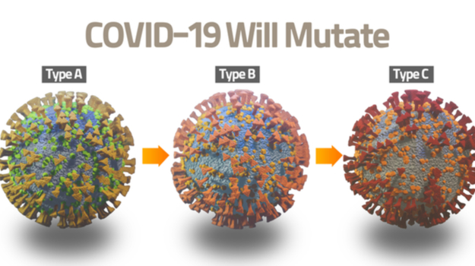

Table of Contents

**INTRODUCTION** 3

**AIM OF THE PROJECT** 3

**COMPLETE PROJECT DETAILS** 4

**COMPLEXITY AND DATA STRUCTURES** 5

**IMPLEMENTATION (CHARTS/ALGORITHM)** 6

**1. GENERATION 1** 7

ASSUMPTIONS 7

**2. GENERATION 2** 11

ASSUMPTIONS 11

**3. RECOVERED** 14

ASSUMPTIONS 14

**4. VACCINATED** 17

ASSUMPTIONS 17

**5. DIED** 20

ASSUMPTIONS 20

**6. DELTA VARIANT** 23

ASSUMPTIONS 23

**UNIT TESTS CASES** 26

CONCLUSION 28

REFERENCES 29

## **INTRODUCTION**

All viruses – including SARS-CoV-2, the virus that causes COVID-19 – evolve over time. When a virus replicates or makes copies of itself, it sometimes changes a little bit, which is normal for a virus. These changes are called “mutations”. A virus with one or more new mutations is referred to as a “variant” of the original virus

Most viral mutations have little to no impact on the virus’s ability to cause infections and disease. But depending on where the changes are located in the virus’s genetic material, they may affect a virus’s properties, such as transmission (for example, it may spread more or less easily) or severity (for example, it may cause more or less severe disease).

## **AIM OF THE PROJECT**

Our objective is to study the evolution of variants of the SARS-CoV-2 virus having a genome consisting of almost 30,000 bases (i.e. A, C, G, or T) with 10 individual genes, on these potential hosts will be either (a) naive (i.e. not infected, not vaccinated), (b) previously infected, (c) vaccinated, (d) previously infected and vaccinated. Implementing the genetic algorithm to evolve new variants and simulating the virus evolution on the host population. And to simulate the virus transmission of SARS-CoV-2, the pathogen behind COVID-19. The simulations take into account different measures taken throughout the pandemic including no restrictions, lockdown, quarantine, social distancing, mask-wearing, testing, and vaccinations.

## **COMPLETE PROJECT DETAILS**

* **Genetic Algorithm:** Genetic algorithms are designed to solve problems by using the same processes as in nature — they use a combination of selection, recombination, and mutation to evolve a solution to a problem. Genetic algorithms are a part of evolutionary computing, which is a rapidly growing area of artificial intelligence.

An algorithm starts with a set of solutions (represented by viruses) called population. Solutions from one population are taken and used to form a new population, as there is a chance that the new population will be better than the old ones are a part of evolutionary computing, which is a rapidly growing area of artificial intelligence. An algorithm starts with a set of solutions (represented by individuals) called population. Solutions from one population are taken and used to form a **new variant**, as there is a chance that the new population will be better than the old one.

* **Fitness Function:** We have measured the fitness defined for virus and host population to explain disease transmissibility and immunity, which indicates how non-infected people were infected by the different variants of viruses. Assuming fitness between (300 – 1000). We have 12 fitness functions for each kind of host and genome type.
* **Mutation:** In certain new offspring formed, some of their genes can be subjected to a **mutation** with a 1/3 of 30,000 probability. This implies that some of the genes in the genotype string can be flipped. Mutation occurs to maintain diversity within the population and prevent premature convergence.

## **COMPLEXITY AND DATA STRUCTURES**

Given the usual choices (point mutation, one-point crossover, roulette wheel selection) a Genetic Algorithms complexity is **O(g(nm + nm + n))** with g the number of generations, n the population size and m the size of the individuals.

***Fitness Function = 12 * O(n)***

Therefore, the complexity is on the order of **O(g(nm)).**

HASH TABLE

We are using this data structure for saving the virus genotype as key and value as a list of 12 fitness functions. Thus, it becomes a data structure in which insertion and search operations are very fast irrespective of the size of the data. Hash Table uses an array as a storage medium and uses a hash technique to generate an index where an element is to be inserted or is to be located from.

Hash tables suffer from **O(n)** worst time complexity:

1. If too many elements were hashed into the same key: looking inside this key may take O(n) time.
2. Once a hash table has passed its [load balance](http://en.wikipedia.org/wiki/Load_balancing_%28computing%29) - it must rehash

However, it is said to be **O(1)** average and amortized case because:

1. It is very rare that many items will be hashed to the same key [if you chose a good hash function and you don't have too big a load balance.
2. The rehash operation, which is O(n), can at most happen after n/2 ops, which are all assumed O(1):
3. Thus, when you sum the average time per operation, you get:

***(n*O(1) + O(n)) / n) = O(1)***

## **IMPLEMENTATION (CHARTS/ALGORITHM)**

In this project, we will be doing Viral Simulation using a Genetic Algorithm. We will be initializing the population, calculating fitness. We will be showing various evolution like Naïve, Infected, Recovered, Vaccinated, Died, and Delta Variant. Along with that we are also showing Graph1 for Infected, Recovered, Vaccinated, Died individuals. Graph2 and Graph3 will be showing Fitness generation for variants 1 and 2 respectively and Graph 3 is showing fitness generation for the Delta variant.

We have studied the modelling of the COVID-19 epidemic and the implementation of steps to combat the virus at the scale of the population. Our model consists of we have considered the following stages:

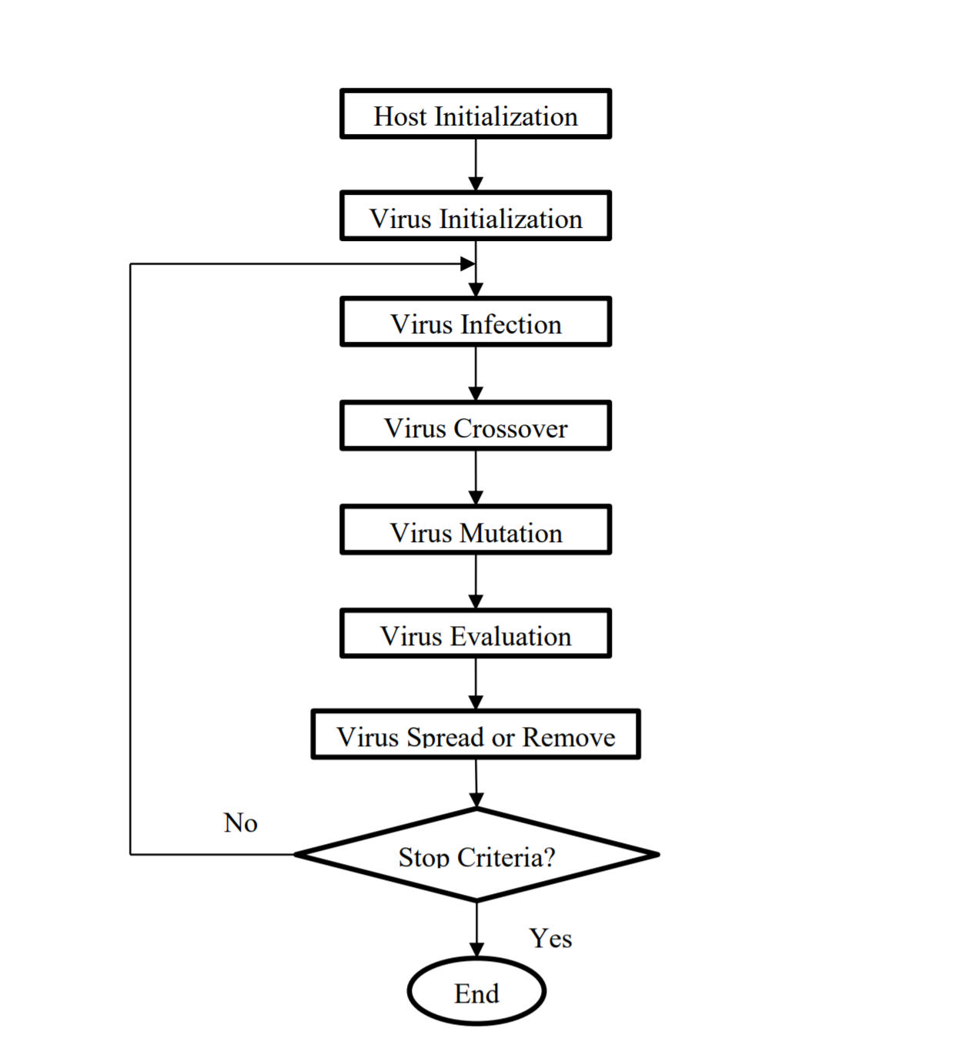

Figure Flow Chart

## **1. GENERATION 1**

### ASSUMPTIONS:

We start with running a genetic algorithm by randomly creating a virus using 4 genotypes (A, C, G, T). Initializing the host population (1000) and randomly assigning them the fitness and 4 genes (A1, A2, B1, B2). Assume a minimum proximity distance of 10 units between two people to become infected. There is a high risk of disease transmission when an infected individual comes into contact with another within this radius of the infected, as seen in the graph.

CONSOLE OUTPUT:

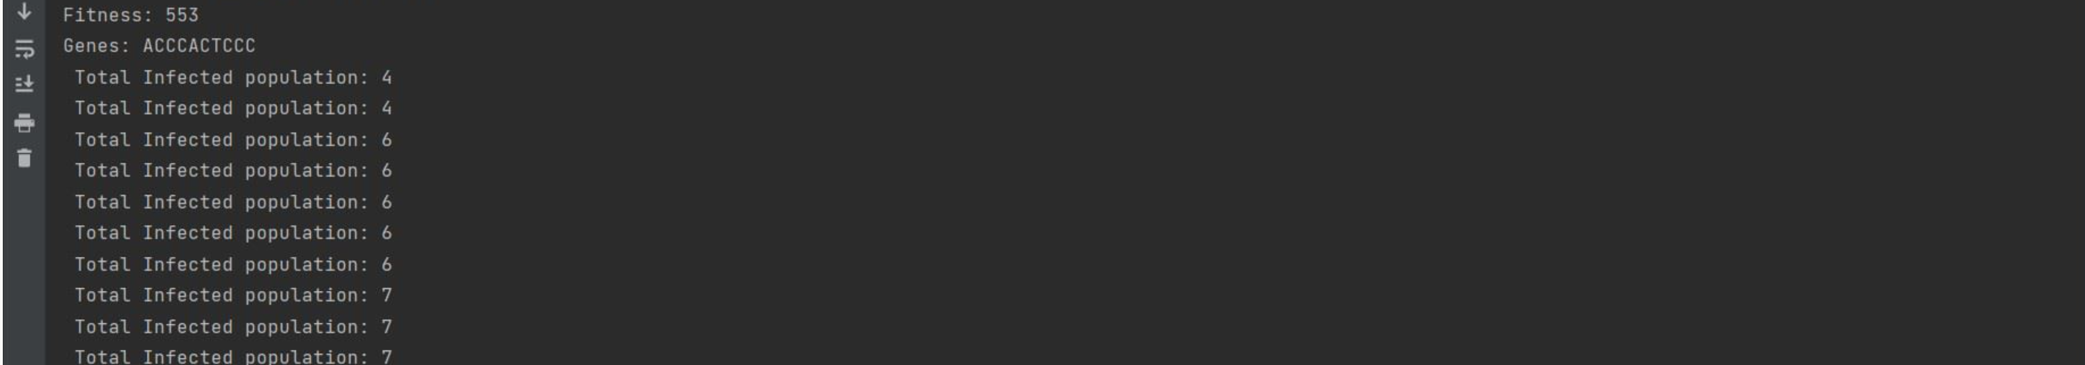

Figure Generation 1 Infection

FOR FIRST GENERATION:

Generation: 0 Fittest: 504

Generation: 1 Fittest: 485

Generation: 2 Fittest: 485

Generation: 3 Fittest: 485

Generation: 4 Fittest: 485

Generation: 5 Fittest: 485

Generation: 6 Fittest: 439

Generation: 7 Fittest: 410

Generation: 8 Fittest: 410

Generation: 63 Fittest: 486

Generation: 64 Fittest: 419

Generation: 65 Fittest: 419

Generation: 66 Fittest: 419

Generation: 67 Fittest: 419

Generation: 68 Fittest: 503

Generation: 69 Fittest: 503

…….

. …..

…….

. …..

…….

Generation: 93 Fittest: 419

Generation: 94 Fittest: 486

Generation: 95 Fittest: 534

Generation: 96 Fittest: 534

Generation: 97 Fittest: 553

Generation: 144 Fittest: 465

Generation: 145 Fittest: 503

Generation: 146 Fittest: 503

Generation: 147 Fittest: 532

Generation: 148 Fittest: 486

Generation: 149 Fittest: 486

Generation: 150 Fittest: 486

Generation: 151 Fittest: 553

**Solution found in generation: 151**

**Fitness: 553**

**Genes: ACCCTCCCAC**

CHART (First new Variant)

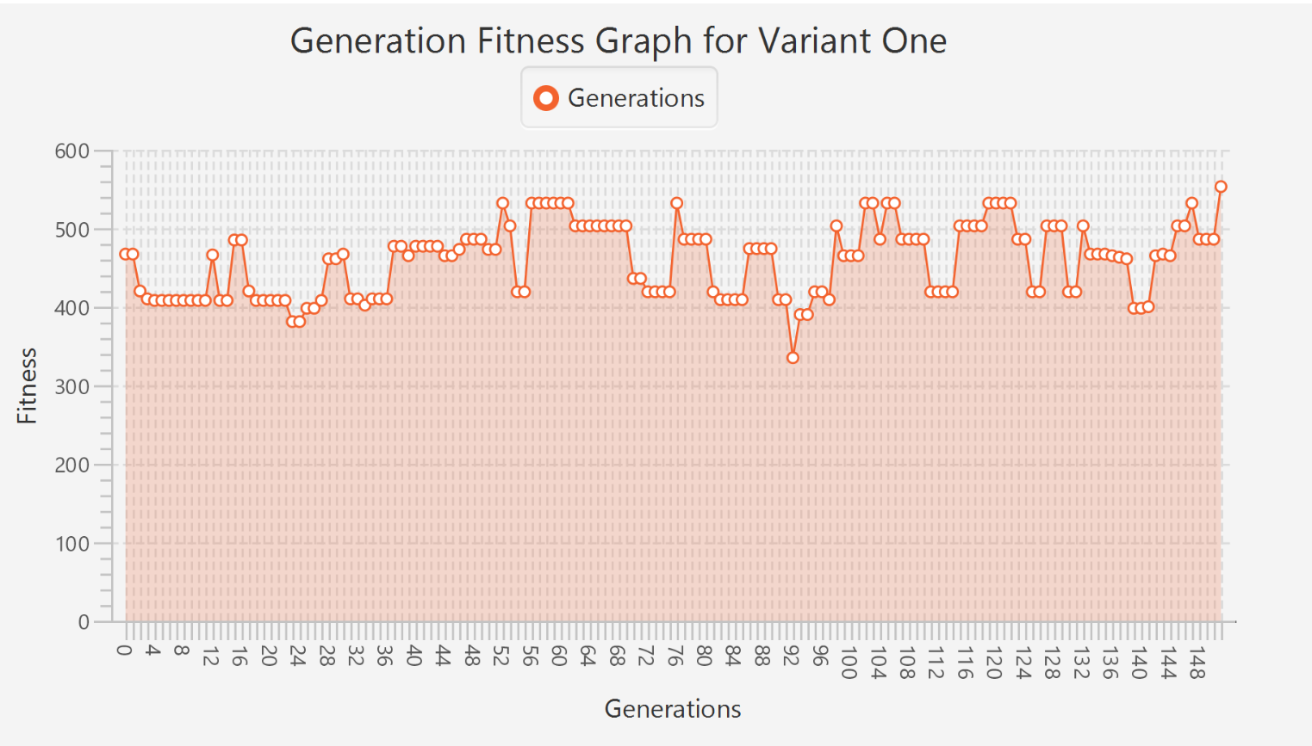

Figure Number of Generation

SIMULATION

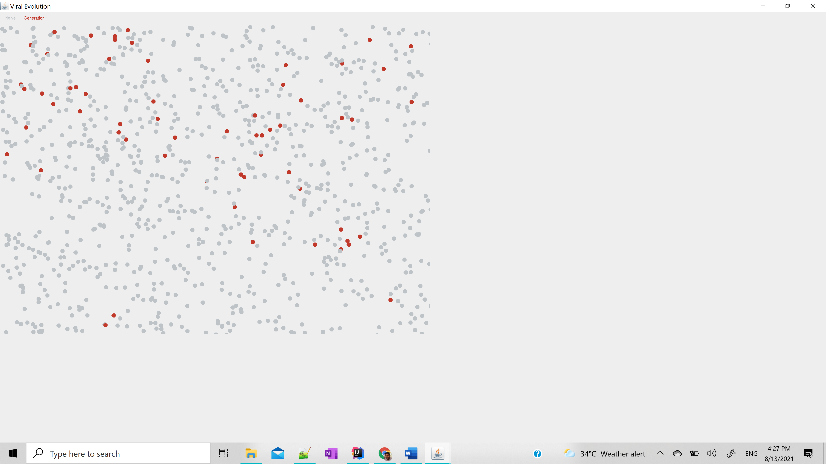

Figure Generation One Infection

CONCLUSION GENERATION 1 VIRUS

The genetic algorithm found the first fittest virus on the 97th generation that can be visualized in the Generation Fitness graph of variant one. The host (naïve) population shown in grey and host population whose fitness is less than the virus will get affected and shown in brown. We can see in the simulation that 7-10 % host population is getting affected by generation 1.

## **2. GENERATION 2**

### ASSUMPTIONS:

We assume that 10% of the population would be affected by generation 1. After a span of 3 months, we call a genetic algorithm to perform mutation and evolve the second generation that is fitter than generation 1.

OUTPUT

CONSOLE OUTPUT

Generation: 0 Fittest: 485

Generation: 1 Fittest: 491

Generation: 2 Fittest: 485

Generation: 3 Fittest: 485

Generation: 4 Fittest: 463

Generation: 5 Fittest: 436

Generation: 6 Fittest: 430

Generation: 7 Fittest: 422

Generation: 8 Fittest: 422

Generation: 9 Fittest: 422

Generation: 10 Fittest: 422

Generation: 11 Fittest: 422

Generation: 12 Fittest: 422

Generation: 13 Fittest: 422

Generation: 14 Fittest: 418

Generation: 15 Fittest: 408

Generation: 16 Fittest: 408

Generation: 17 Fittest: 408

………

Generation: 108 Fittest: 532

Generation: 109 Fittest: 467

Generation: 110 Fittest: 467

Generation: 111 Fittest: 553

**Solution found in generation: 111**

**Fitness: 553**

**Genes: CCCATCACCC**

CHART

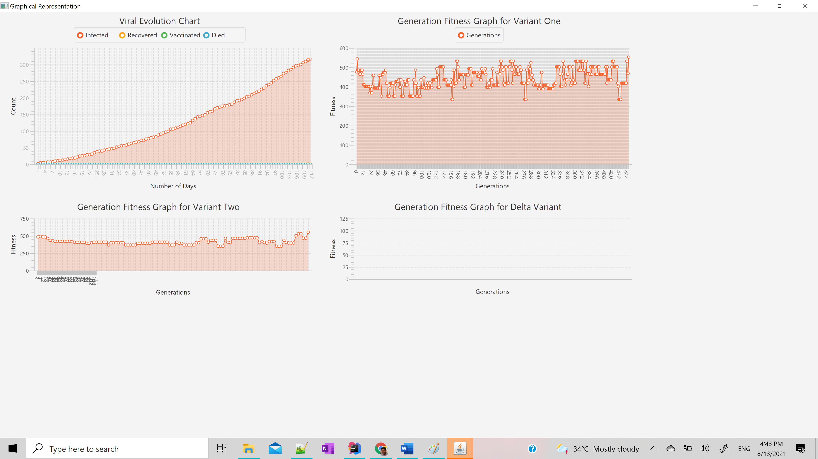

Figure Number of Generation

SIMULATION

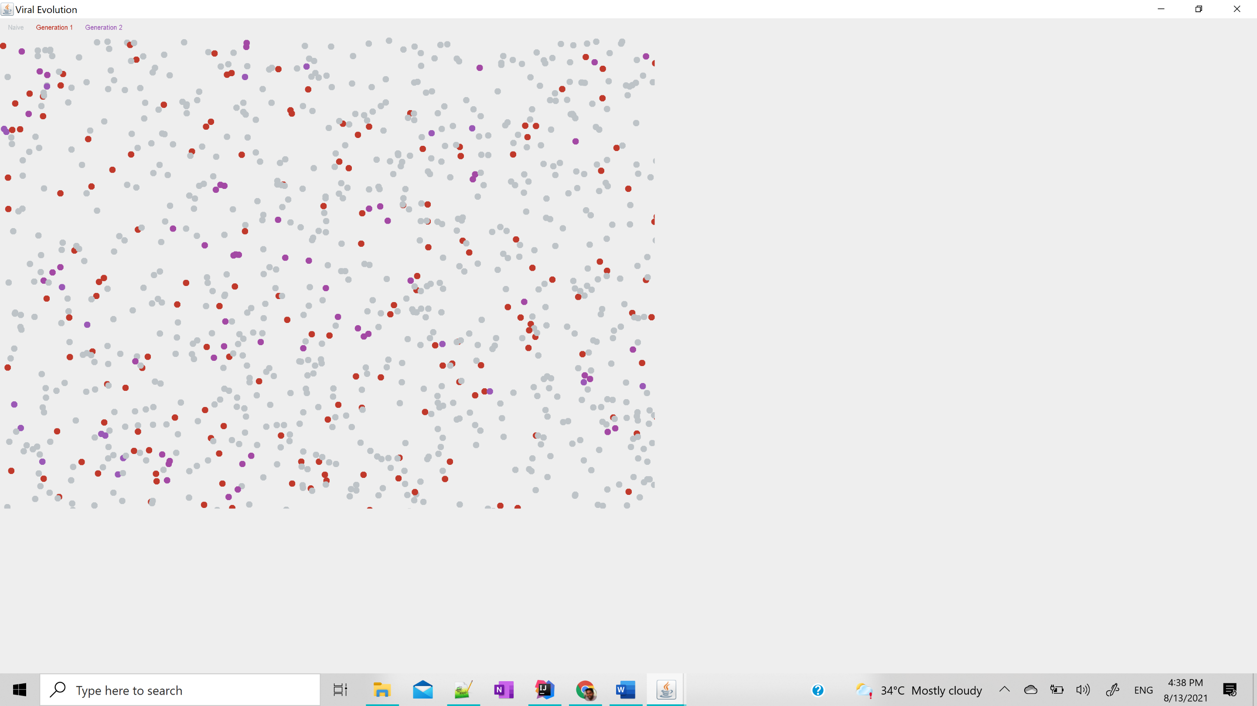

Figure Generations Infections

**CONCLUSION GENERATION 2**

After generation 2 viral evolution it starts affecting the host population whose fitness is less than generation 2 woold get affected and start getting converted in purple. We can see in the chart that at 111th generation we found generation 2. In the simulation we can see about 15% of the host population is affected by 2nd covid variant.

## **3. RECOVERED**

## ASSUMPTIONS:

After getting affected by 2 different variants some of the host population who has good immunity would start recovering.

OUTPUT

CONSOLE OUTPUT



Figure Recovered

CHART

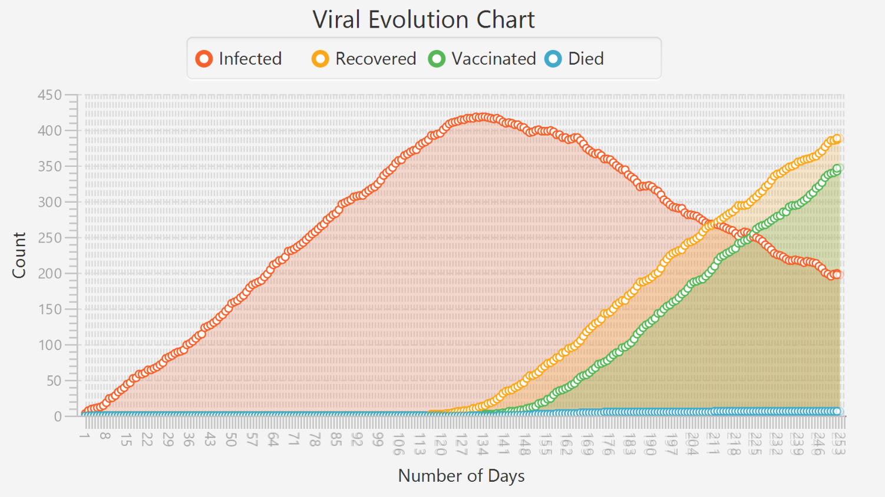

Figure Viral Evolution

SIMULATION

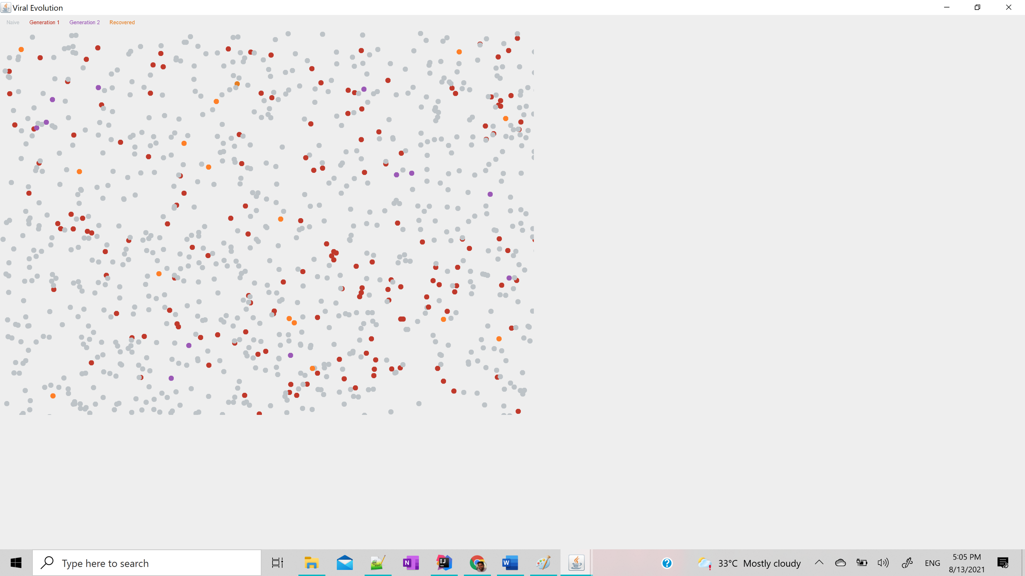

Figure Recovered Population with Infected

**RECOVERED CONCLUSION**

Over the period of time, we can see some of the host population is getting recovered because of their good immunity. We can see in the chart that the recovery graph has started making linear progress and forming a curve. In the simulation we can see about 5% for of host population is getting recovered.

## **4. VACCINATED**

### ASSUMPTIONS:

After a span of one year (300 days ), scientists and WHO were able to figure out the vaccine. Gradually people started getting the vaccine and they are becoming immune to Covid-19 by boosting their immunity and increasing their fitness above the virus.

OUTPUT

CONSOLE OUTPUT



Figure Vaccinated

CHART





Figure Viral Evolution

SIMULATION

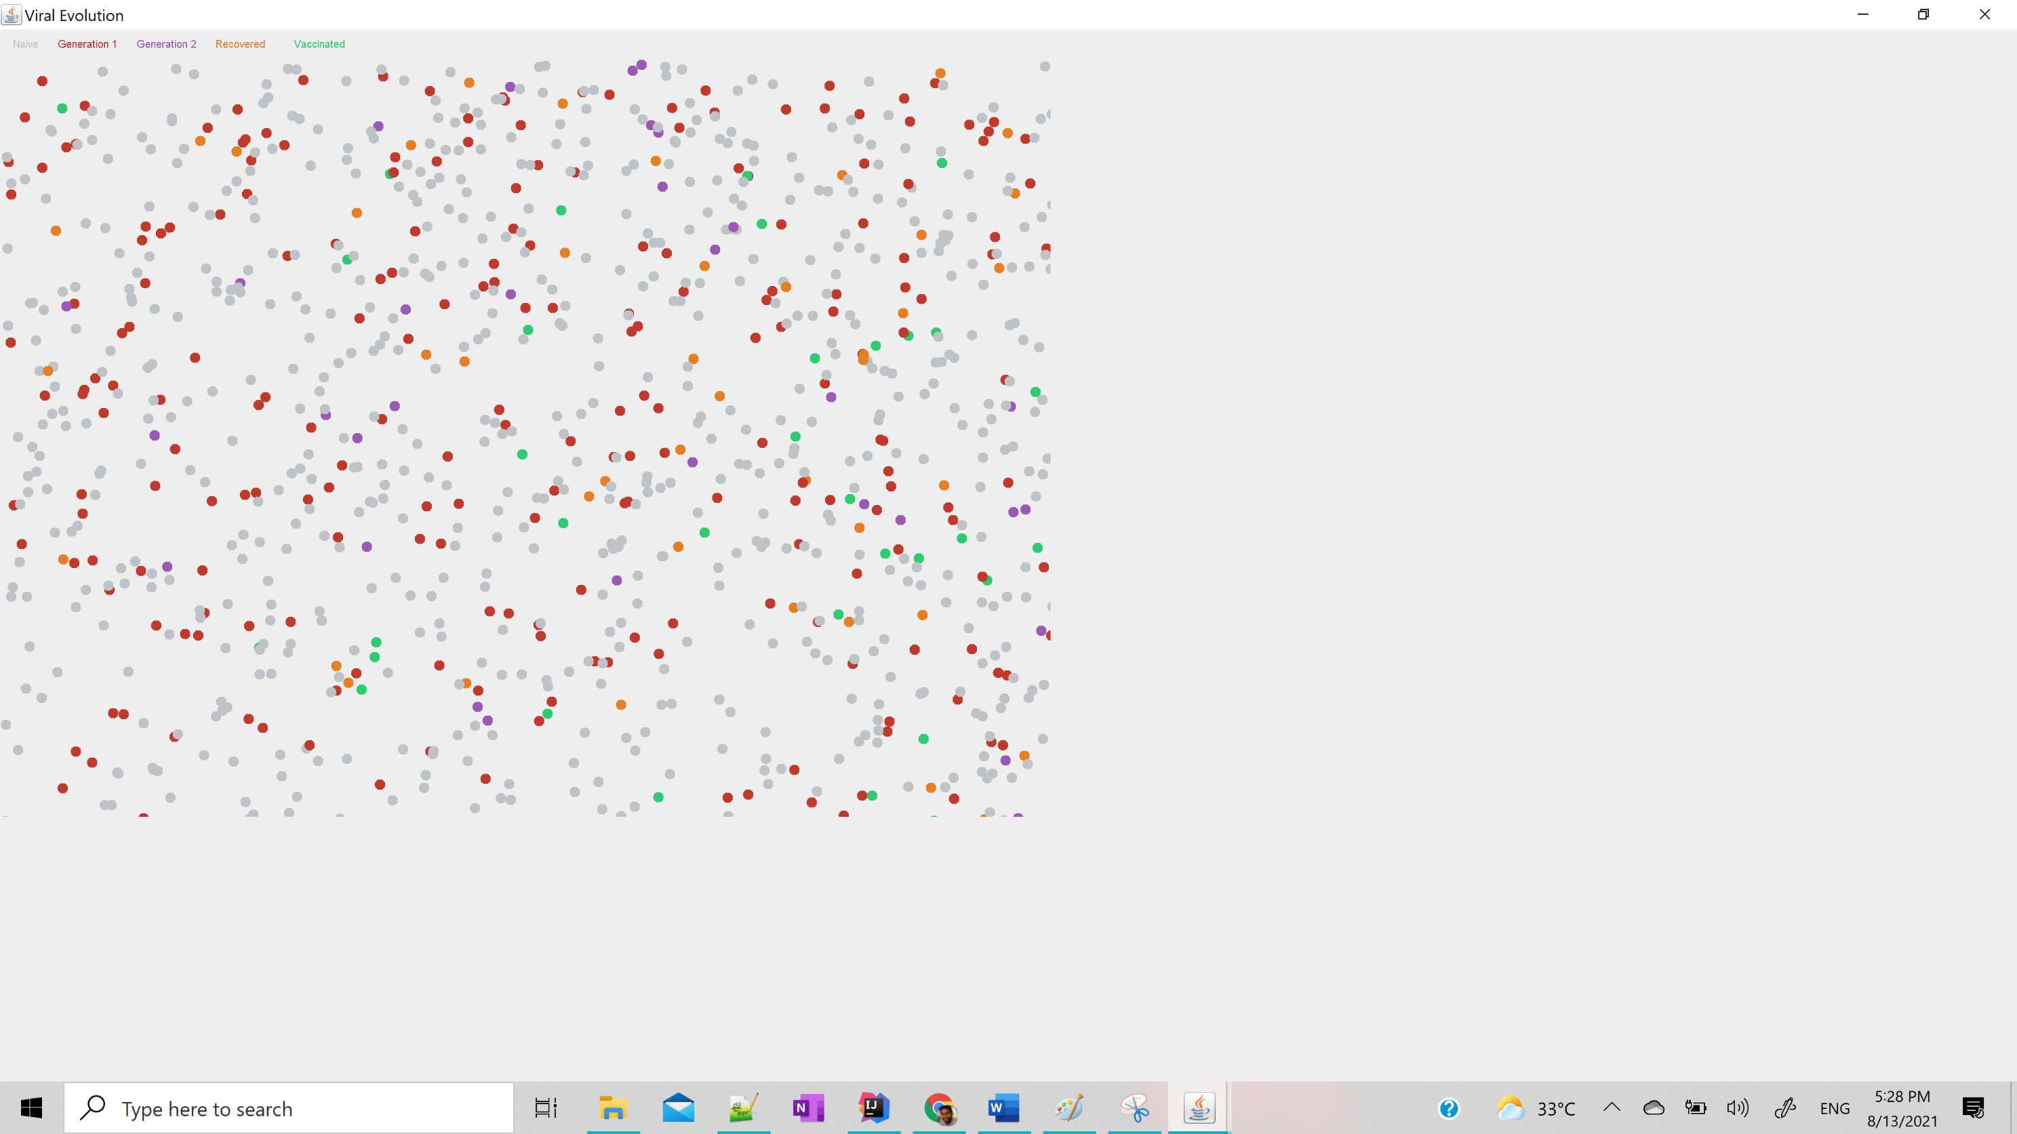

Figure Vaccinated, Recovered with Infected

**VACCINE CONCLUSION**

With some of the host population getting recovered, and by start giving the vaccine to host population we can see that people are becoming more immune. In the chart we can see that with recovered vaccination is also improving gradually and making a linear growth. In simulation, we can see that brown and purple (infected host) were getting converted to orange(recovered) and green (vaccinated).

## **5. DIED**

### ASSUMPTIONS:

After being affected by Covid-19, some the host population who were having less immunity because of some already suffering diseases were died.

OUTPUT

CONSOLE OUTPUT



Figure Died

CHART

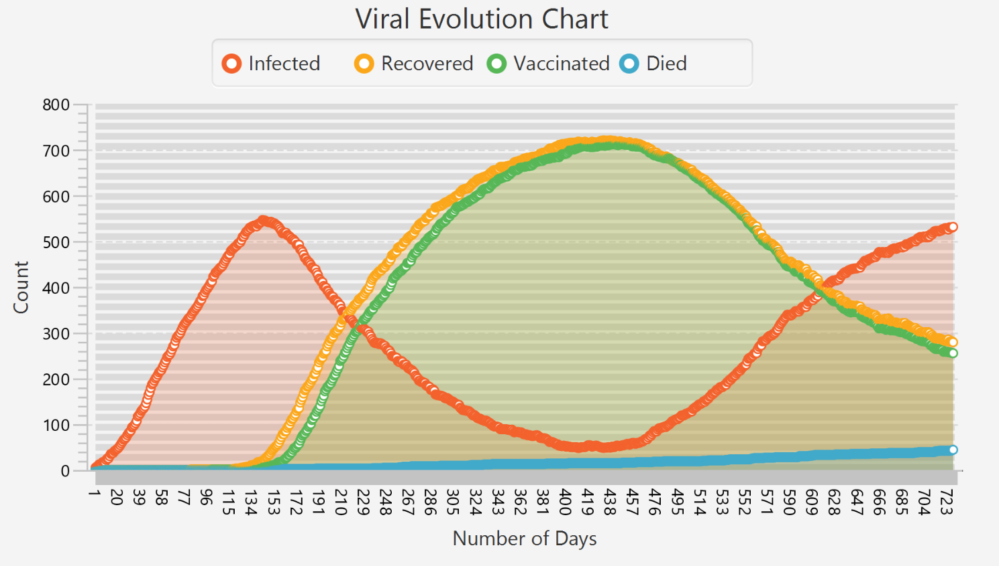

Figure Viral Evolution

SIMULATION

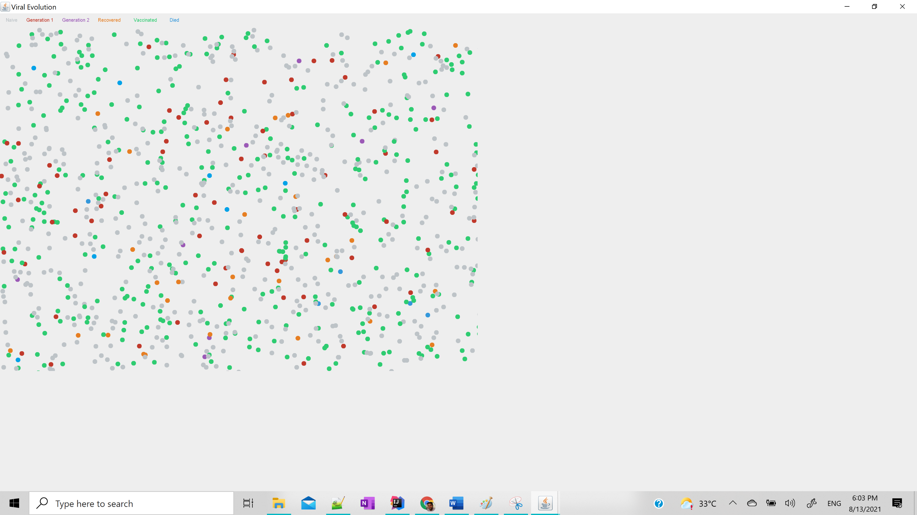

Figure Died with Recovered, Infected, Vaccinated

**DIED CONCLUSION**

Two Covid-19 generations are killing 2% host population of low immunity. In the chart, we can see the blue graph has started making slow progress. In the simulation we can that the blue colour is not moving, and they are dead.

## **6. DELTA VARIANT**

### ASSUMPTIONS

After a year (around 400 days), there is the evolution of a new variant that has more fitness that could affect the vaccinated people as well. It has more mortality rate, more spreading rate.

OUTPUT

CONSOLE OUTPUT

Generation: 0 Fittest: 467

Generation: 1 Fittest: 428

Generation: 2 Fittest: 493

Generation: 3 Fittest: 493

Generation: 4 Fittest: 493

Generation: 5 Fittest: 493

Generation: 6 Fittest: 493

Generation: 7 Fittest: 493

Generation: 8 Fittest: 428

Generation: 9 Fittest: 428

Generation: 10 Fittest: 428

Generation: 11 Fittest: 428

Generation: 12 Fittest: 409

Generation: 13 Fittest: 474

Generation: 14 Fittest: 474

………..

Generation: 4038 Fittest: 534

Generation: 4039 Fittest: 534

Generation: 4040 Fittest: 534

Generation: 4041 Fittest: 534

Generation: 4042 Fittest: 534

Generation: 4043 Fittest: 534

Generation: 4044 Fittest: 601

**Solution found in generation: 4044**

**Fitness: 601**

**Genes: ACCCCCCCCT**

CHART

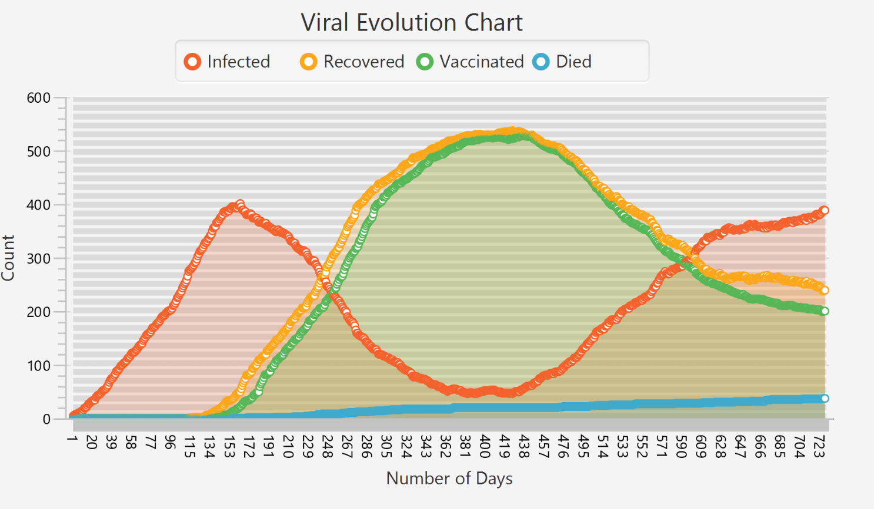

Figure Viral Evolution

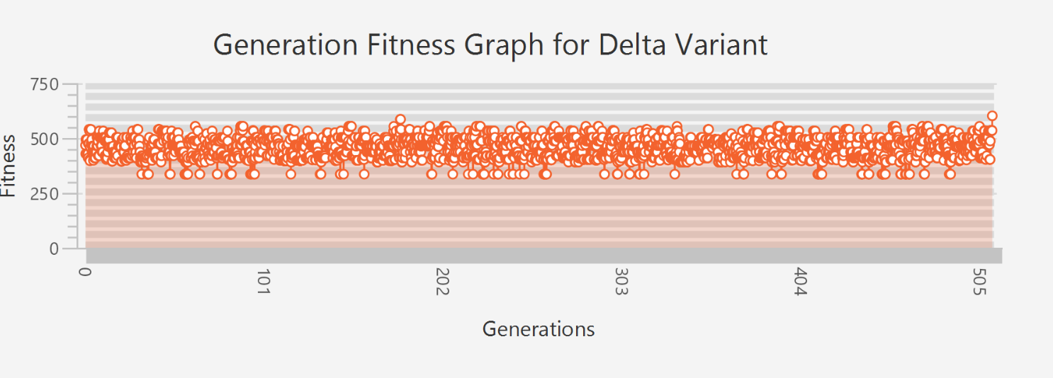

Figure Number of Generation for Delta

SIMULATION

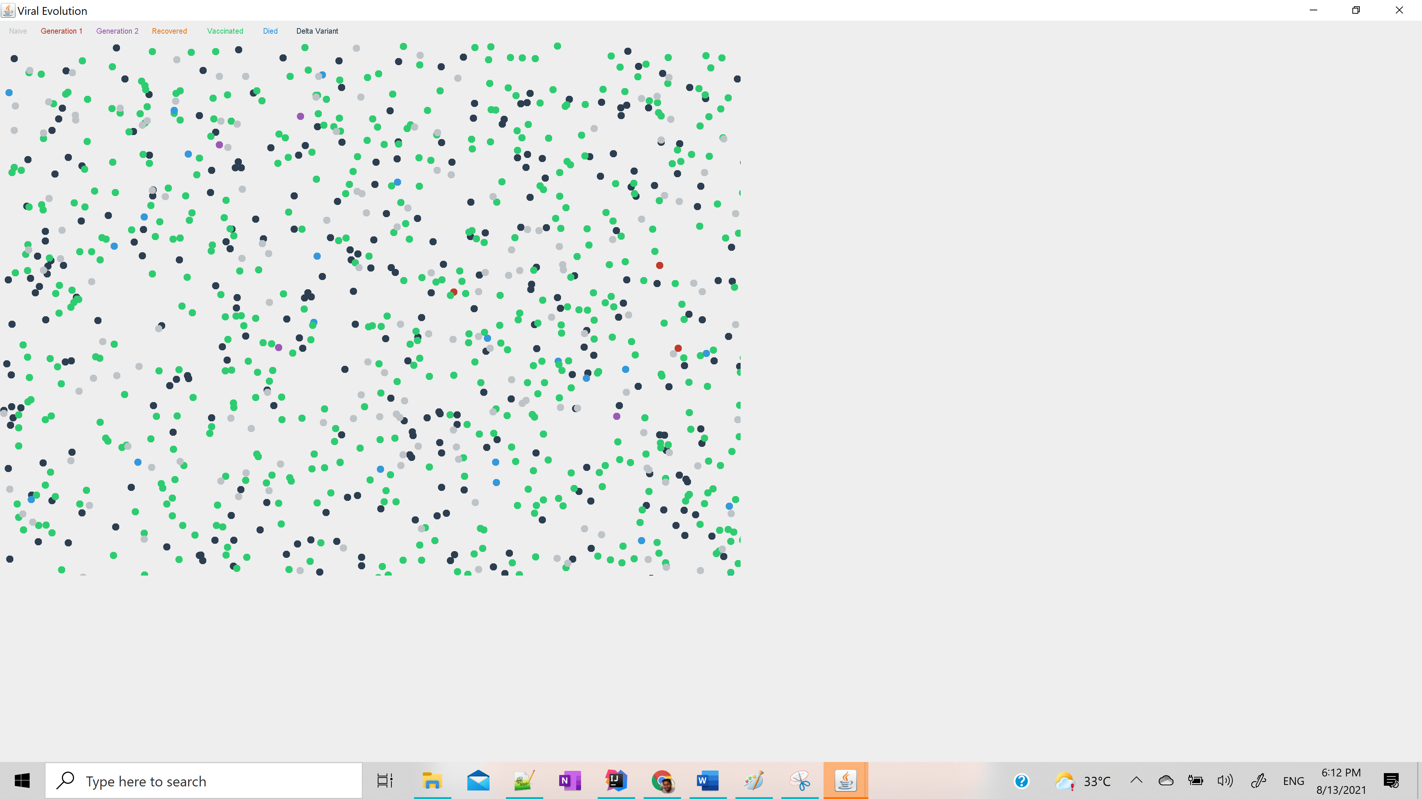

Figure Delta Variant with Others

**DELTA VARIANT CONCLUSION**

Hence, we can see the delta variant of Covid-19 is becoming more dominant and causing infection to even vaccinated host population. We can see in the graph the infection rate is again going up and recovered/vaccinated is going down. In the simulation, we can see that the black colour (delta variant) is affecting all kinds of genotypes of the host population including vaccinated and recovered.

## **UNIT TESTS CASES**



Figure Test Case 1

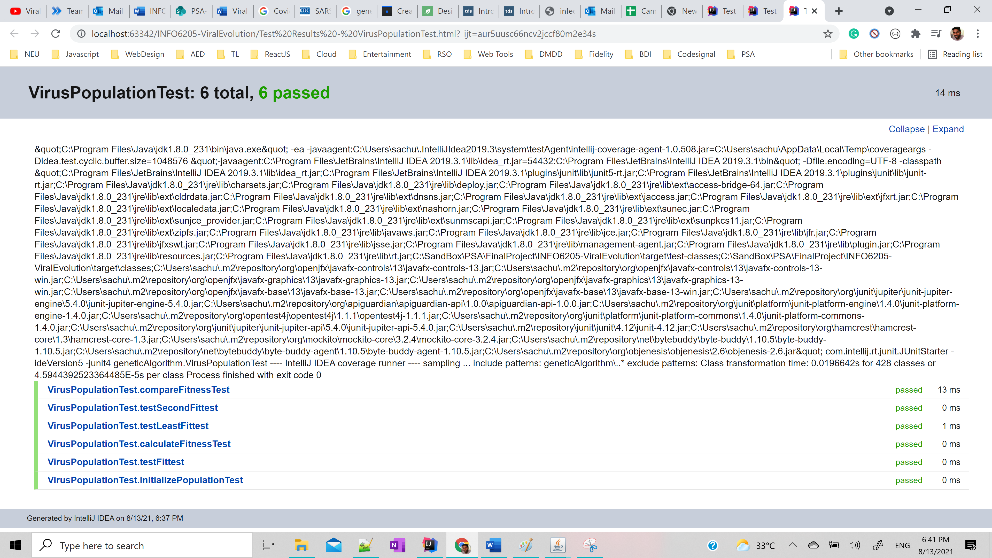

Figure Test Case 2



Figure Test Case 3

## CONCLUSION

From the simulation, we concluded that SARS-CoV-2 virus is highly infected but then too its infection depends on host type fitness. We ran Genetic Algorithm to create a different virus variant and show how it spread in different host. We also notice vaccination play big role to help stop spread virus infection. Eventually after a while the virus increase its fitness after infecting the host creating a more powerful virus variant which we labeled as Delta variant, even vaccinated people can get infected by delta variant.

***Genetic Algorithm***

* ***Invariant***
  + A genetic algorithm is invariant with respect to a set of representations if it runs the same no matter which of the representations is used. We formalize this concept mathematically, showing that the representations generate a group that acts upon the search space. Invariant genetic operators are those that commute with this group action. We then consider the problem of characterizing crossover and mutation operators that have such invariance properties. In the case where the corresponding group action acts transitively on the search space, we provide a complete characterization, including high-level representation-independent algorithms implementing these operators.
* ***Termination***
  + A solution is found that satisfies minimum criteria
  + Fixed number of generations reached
  + Allocated budget (computation time/money) reached
  + The highest ranking solution's fitness is reaching or has reached a plateau such that successive iterations no longer produce better results
  + Manual inspection
  + Combinations of the above

## REFERENCES

* <https://www.ai.uga.edu/sites/default/files/inline-files/Weixin_Ling_Thesis_1116.pdf>
* <https://en.wikipedia.org/wiki/Genetic_algorithm>
* <https://genome.ucsc.edu/cgi-bin/hgTracks?db=wuhCor1&lastVirtModeType=default&lastVirtModeExtraState=&virtModeType=default&virtMode=0&nonVirtPosition=&position=NC_045512v2%3A1%2D29903&hgsid=1133869119_bR5bzYzNJAGr0pkslyjYXazsVtAZ>
* <https://towardsdatascience.com/how-to-define-a-fitness-function-in-a-genetic-algorithm-be572b9ea3b4>